IMAP² SUMMER JUNE 2008 INSTITUTE
TRIGONOMETRY FOURIER SERIES
NOTES ON STANDARD WAVE FORMS
WS 06-17-08
The standard wave forms, sine, square, triangle and sawtooth are shown below. Fourier series for those are given below the graphics.

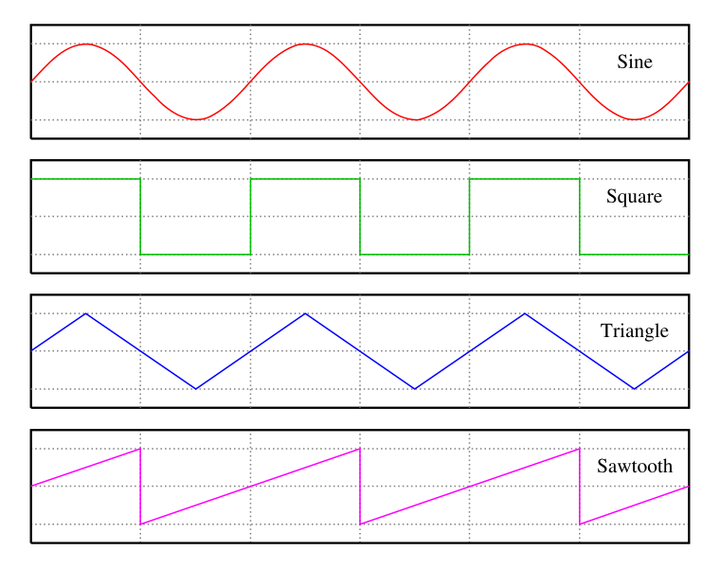

See also SUMMARY: Formulas for standard wave form Fourier series. Cf http://mathworld.wolfram.com/FourierSeries.html
1. SAWTOOTH WAVE
Define by f[x] = x for x  (-,  ) (not defined at - or ), extend periodically: f [ x + 2  ] = f [ x ] for all x  m* , m an integer.

Fourier series:

f [ x ] = 2* (sin[x] -$\frac{\text{sin}[2x]}{2}$+ $\frac{\text{sin}[3x]}{3}$- $\frac{\text{sin}[4x]}{4}$+…)

= $2∗\sum{(−1)^{n+1}}$$\frac{\text{sin}[\text{nx}]}{n}$

Note that this Fourier series expression makes sense for all real x, and would give f [ m*  ] = 0 .

2. SQUARE WAVE
Define

f[x] = 1 for x  ( 0,  )

f[ x ] = -1 for x  ( -  , 0 )

(not defined at -, 0 or ), extend periodically: f [ x + 2  ] = f [ x ] for all x  m* , m an integer.

Fourier series:

f [ x ] = $\frac{4}{π}$* (sin[x] + $\frac{\text{sin}[3x]}{3}$+ $\frac{\text{sin}[5x]}{5}$+…)

=$\frac{4}{π}$ $\frac{\text{sin}[(2∗n−1)x]}{2n−1}$

Note that this Fourier series expression makes sense for all real x, and would give f [ m*  ] = 0 .

3. TRIANGLE WAVE

Define by

f[x] = | x | for x  [ -  ,  ]

extend periodically: f [ x + 2  ] = f [ x ]

Fourier series:

f [ x ] = $\frac{π}{2}$- $\frac{4}{π}$* (cos[x] + $\frac{\text{cos}[3x]}{3^{2}}$+ $\frac{\text{cos}[5x]}{5^{2}}$+ …)

=$\frac{π}{2}$- $\frac{4}{π}$ $\frac{\text{cos}[(2∗n−1)x]}{(2n−1)^{2}}$

For additional worked out examples see http://www.exampleproblems.com/wiki/index.php/Fourier_Series

