Statistical Methods of Computing
Final Project

Joe Bretthauer
Brad Goetz
Mark Hoy
Greg Neiswander

05/01/06
Table of Contents
Intro 2
Background 2
Input 5
Statistical Analysis Methods 5
Results 6
Discussion 7
Appendix A: Data 8
Appendix B: SAS Output with Full Dataset 9
Appendix C: SAS Output without Outlier 11

Intro
The purpose of this project was to perform an experiment on real life data and analyze it using statistical methods. The performed experiment seeks to determine whether or not one variable can be an accurate predictor of the effectiveness of one countermeasure for spatial disorientation during flight compared to another. Three alternatives to the baseline variable, round dials, were compared: tactors, which uses seat vibration to tell the pilot how to correct the plane; aural, which uses verbal cues to tell the pilot how to correct the plane; and synthetic vision (SVS), which shows a computer model of the environment exterior to the plane. Each of the three alternatives was compared only to the baseline, round dials, with time to recovery being the variable used for comparison.

Background
Spatial Disorientation in aviation occurs when an aircraft moves into an awkward and unsafe flying position without the pilot’s awareness. The pilot may lose ability to distinguish up from down and left from right, therefore becoming spatially disoriented. This problem occurs mostly in poor weather conditions and poor visibility conditions. Loss of the ability to differentiate the planes position via the horizon leads to severe loss of flight control with potentially fatal results. The biggest problem with spatial disorientation is the broad range of pilots whom are affected. This is not a simple case in which the problem is solved through age and experience. Spatial disorientation may occur to all levels of pilots ranging on all levels of age and experience.
Currently the Operator Performance Laboratory (OPL), located at the University of Iowa Engineering Research Facility and at Iowa City Airport, is working on the development of countermeasures aimed at limiting the effects of spatial disorientation. Through funding by NASA and Rockwell Collins, three proposed systems were developed and are in testing phases. The three systems are an audio verbal warning system, a vibrating tactor seat system, and a synthetic vision system (SVS).
The verbal warning system was created by pre-recording various messages to warn the pilot (example: if plane falls into a steep left hand bank, the voice will come on over the radio and say “excessive bank, roll right.”). These messages are programmed to play depending on the planes position and its control input.
The next warning system is a tactor seat system. It is essentially a set of cell phone vibrators that are embedded into a seat cushion. The tactors will activate if the plane moves into an unsafe attitude (example, tactors on right side of the cushion will activate or tactors on left hand side of cushion will activate).
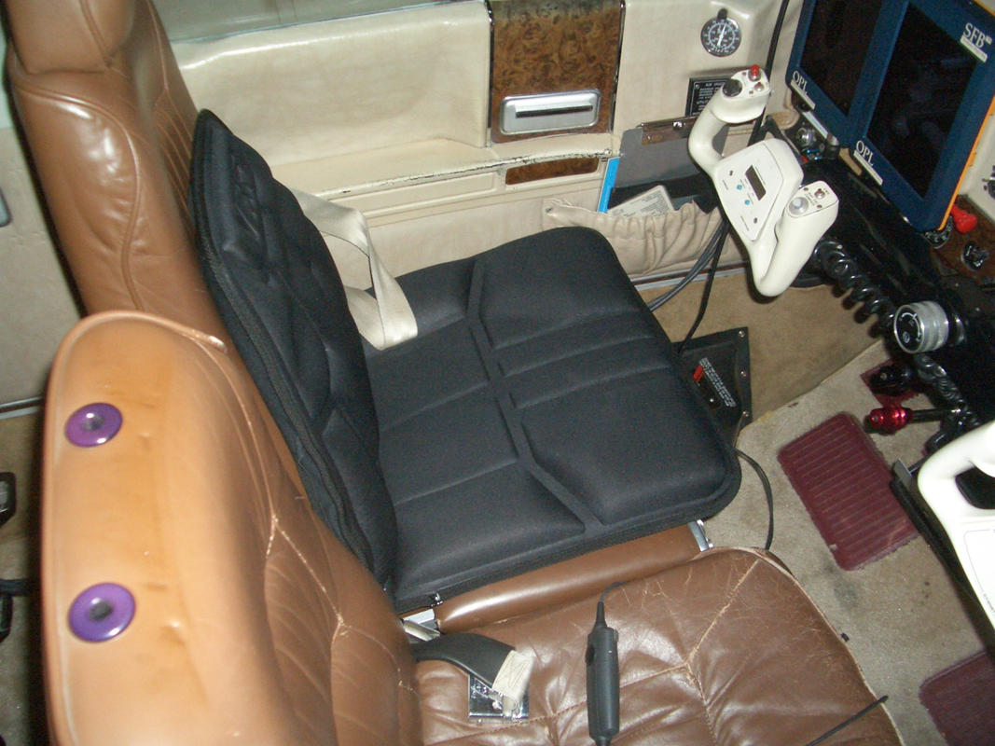
Figure 1: Tactors Seat Countermeasure System
The synthetic vision system is a comprehensive flight software developed at OPL. The SVS uses a flight bag display to present the information (see Figure 2), another instrument designed at OPL. The SVS displays a 3D virtual environment of the surrounding area (much like what you would see in a flight simulator video game). It also displays essential flight information such as a heading indicator, altimeter, and airspeed indicator. If the plane falls into an unsafe or unusual position a red arrow will appear on the screen indicating which direction to turn.

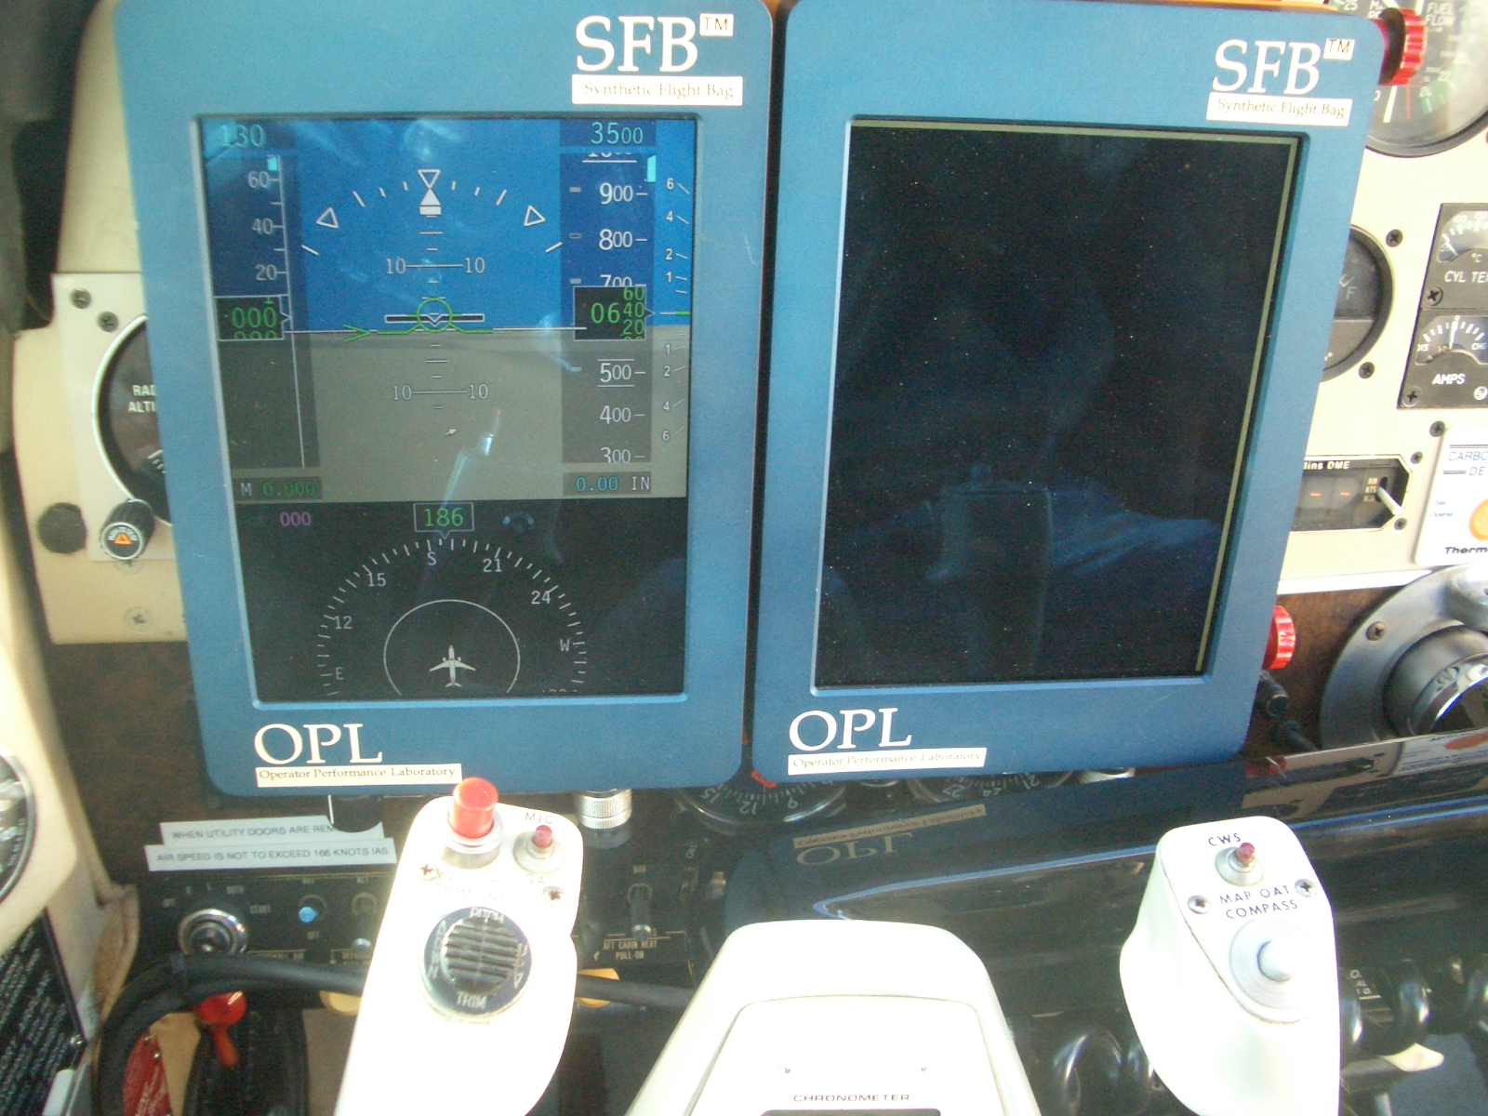
Figure 2: Flight Bags with Synthetic Vision System

These three countermeasures needed a baseline variable to be compared to. Round flight dials were chosen to be the baseline variable because of the common availability of the dials in a normal aircrafts instrument panel. Most pilots are trained and are accustomed to using these dials. A synthetic display of dials were created and displayed on the Flight Bag system (for ease of testing).

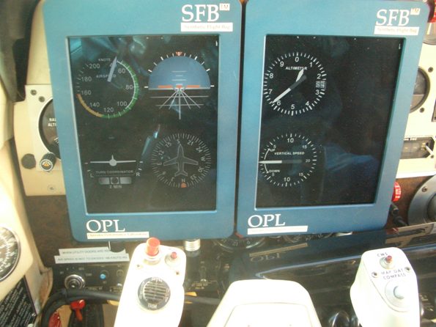
Figure 3: Baseline Round Dials Display

Using these four countermeasures (including the baseline round dials) an experiment was conducted by means of flight tests. Twelve pilots were tested, each ranging in age and skill level. To test the pilots an experimental aircraft (Beechcraft A-36 Bonanza) was used (see Figure 4). Three people went up in each flight test: the safety pilot, the test pilot (the test subject), and a flight test engineer (who ran the equipment in the backseat). The setup of each flight test consisted of a series of runs. Each run included a specific maneuver that was performed. The safety pilot put the plane into a certain position, and then handed the plane over to the test pilot, who had to return the plane back to level flight using the countermeasures. To ensure the pilot could not see out the windows to gain spatial awareness, a hood was used to block his vision. A hood is a pair of glasses that are worn, which blocks out vision from above, but retains vision below (see Figure 6). It enables the test pilot to view his flight displays and controls inside the plane, but keeps him from viewing outside the plane. The test pilot executed 16 different runs during each flight test. In the end, the test pilot had completed different maneuvers with all four types of countermeasures. For this project, only one maneuver was analyzed.
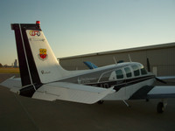
Figure 4: Beechcraft A-36 Bonanza Experimental Aircraft

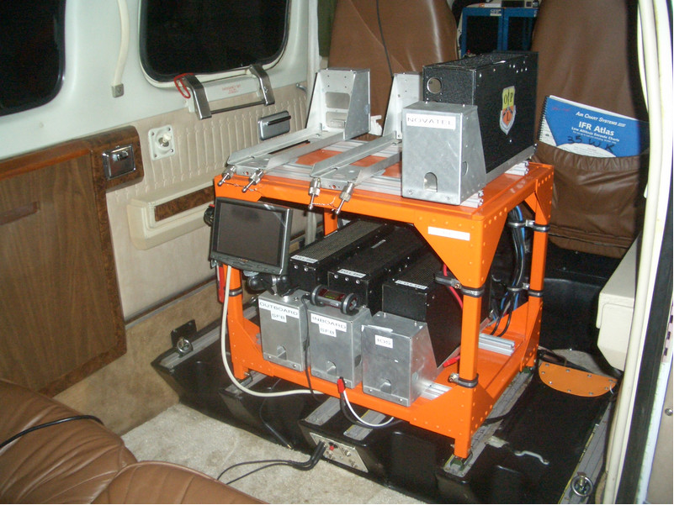
Figure 5: Computers and Equipment in Backseat of Aircraft

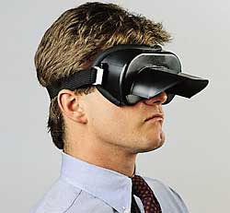
Figure 6: Example of a Hood

All flight information (all input controls, airspeed, roll, pitch, elevation, time, etc) was recorded during each flight test. This flight data provides an exact model of what happened in each run. However, for this project’s scope, interest only lied in the recorded time to recovery. The time to recovery was the span between the exact point at which the test pilot was given control of the aircraft until the plane was handed back over to the safety pilot. These can give a general indication of how well each pilot performed a maneuver using each countermeasure.
For this project, eleven pilots data was gathered for one maneuver (one pilot had to be omitted due to a lack of completed runs). Each pilot had four runs for the maneuver, so in all, forty four time to recoveries were collected.

Input
The first step taken in analyzing the effects of the countermeasures on flight recovery time was to collect data. For this project, the data was collected from actual in-flight measurements of time-to-recovery using four countermeasures; dials, tactors, audio, and SVS. Fortunately, the OPL allowed the use of this data which had been collected earlier from multiple pilots. The data measures the time taken by each pilot to complete the specified maneuver and to position the plane in the neutral position while using each of the listed countermeasures. The data was compiled into a text file, which was separated into countermeasure categories, to be used by the SAS program. The file was then converted to a .dat file and then inputted into SAS. The SAS code is shown in figure 7. The control variable used was the dials countermeasure, which is the standard control setup in most airplanes. The three other countermeasures were then compared to the control variable by taking the differences in times between the three countermeasures and the control variable. Finally, a univariate test was done to determine if there were significant differences between dials and any of the other countermeasures.

options linesize=72;

data pilot;
infile "c:\temp\pilotttr.dat";
input dials tactors audio svs;
difftact = dials - tactors;
diffaud = dials - audio;
diffsvs = dials - svs;
run;

proc univariate plot;
var difftact diffaud diffsvs;
run;
Figure 7: SAS Input Code

Statistical Analysis Methods
The data from the flight tests was analyzed using a paired t-test in SAS. The paired t-test was used because two different population means were being compared in each of the three comparisons that were made. This was a self-pairing t-test because two measurements were made for each pilot when evaluating each of the three alternatives for flight correction (dials vs. tactors, dials vs. synthetic vision, and dials vs. aural). T-tests were done for each alternative, and the p-values were recorded for each. Paired T-tests were done instead of ANOVA because the object was to compare each of the three countermeasures to the baseline, not to each other. To perform the t-tests, the differences in time to recovery for each alternative were made, as shown in figure 7 (indicated by the variables difftact for the difference between dials and tactors, diffaud for the difference between dials and aural, and diffsvs for the difference between dials and synthetic vision). The null hypothesis was that the differences of the means between dials and each of the three alternatives would be zero (Figure 8).
$$\begin{aligned}H_{o}:μ_{\text{base}}=μ_{\text{tact}} \\ \begin{matrix} & \end{matrix}μ_{\text{base}}=μ_{\text{audio}} \\ \begin{matrix} & \end{matrix}μ_{\text{base}}=μ_{\text{svs}}\end{aligned}$$
Figure 8: Null Hypothesis
The proc univariate procedure was then used to compare the difference between the means. This found the t-statistic and the corresponding p-values, which indicate the likelihood that difference between the means could be what the data indicated while the null hypothesis remained true. This was done twice; once including data with a low outlier that skewed the data, and once without the low outlier (the boxplot for tactors vs. dials below shows the outlier). A bonferroni adjustment was then performed on the data, to reduce the likelihood of type-I error. The bonferroni adjustment involved multiplying the p-values by 3, since 3 comparisons were made (the bonferroni adjustment involves simply either multiplying the p-values by the number of comparisons made or adjusting the significance level according to, Equation 1 , where k is the number of comparisons made).
Equation 1: Bonferroni Equation
$$α∗\frac{α}{\frac{k}{2}}$$

Results
The results of the analysis will show if any of the three countermeasures improve the recovery time with statistical significance over the baseline run of round dials. The results will apply only to the recover time using the three new countermeasure options. Any conclusions will be made with a 95% confidence, by using alpha equal to .05. This means that 95% of the time a sample of the same size is gathered on this data; the mean time of the given countermeasure will be statistically different from the mean time of the base line round dials.
When performing hypothesis test using t-tests, the data should be examined to determine whether it is a good candidate for the t-test. Using a t-test assumes that the data follows a normal distribution. Many things can affect the results of the test including outliers in the data; especially when the sample size is small. In reviewing the box plots from the output, there was found to be one outlier in the sample. With a sample size of only eleven, the t-tests were performed with and without the outlier in the dataset. This would show how the outlier affects the data and if any conclusions can be made on whether any of the three countermeasures improve the recovery time.
After analyzing all of the data, the null hypothesis could not be rejected. This means that none of the three countermeasures had statistically different recovery times from the baseline round dials. After using the Bonferroni adjustment the p-values were all fairly large, meaning that the recovery times of the two compared tests are basically the same. The p-values are shown below in Figure 9.

 | P-Values
 | w/ Outlier | Bonferroni Adjusted [x3] | w/out Outlier | Bonferroni Adjusted [x3]
Tactors v Dials | .2867 | .8601 | .0105 | .0315
Audio v Dials | .3805 | >1 | .1196 | .3588
SVS v Dials | .2006 | .6018 | .0930 | .2790
Figure 9: Resulting P-Values

The data was then re-analyzed to see what effect the outlier had on the results. The p-values with the outlier removed came down dramatically. The p-values were adjusted using the Bonferroni adjustment and are shown above in Figure 9. This shows that the null hypothesis can be rejected in the instance of the tactors over the baseline round dials. The p-value is 0.0315 which is below the specified alpha equal to 0.05. The other two countermeasures have p-values greater than 0.05, therefore there is no statistical proof that the recovery times are different from the baseline run. In this instance there were no regrets to throwing out the outlier from the dataset. The values recorded from that test subject were very different from the rest of the test subjects. There could be many reasons why this pilot had very different results that aren’t relevant to this study. One of the possible reasons is that this subject wasn’t open to different ways to fly the plane or did nt understand how to use any of the new countermeasures correctly. For the most part the rest of the test subjects saw and decrease in their response time with the new countermeasures compared to the baseline. The outlier test subject’s response time double instead of decreasing.

Discussion
It was concluded that tactors showed significantly lower recovery times than the control variable. However, there are some important factors to consider about the data before accepting the conclusion. First, as in any analysis, there is bound to be lurking variables. Namely, in this analysis, the age of the pilot may influence the data as some older pilots are unwilling to or have difficulties accepting and using new technologies. The age was not recorded in the data, for privacy reasons, which makes it impossible to correlate the age variable into the data analysis. It could be shown in other experiments that age does or does not play a factor in recovery time using new countermeasures while performing a flight maneuver; however, for this analysis, that could not be determined. Another important issue to consider is that while older pilots have more experience in flying airplanes than the younger pilots, they do not always perform better. Older pilots tend to have slower reaction times and motor skills as these skills tend to degrade as people age. However, this does not mean that the younger pilots will necessarily perform better, as they may be unfamiliar with or untrained in flight maneuvers that the older pilots are experienced in completing.
Another factor to consider is that the analysis is trying to judge complex flight maneuvers using only recovery time. There are many other variables that should be included in an experiment analyzing a complicated flight maneuver. Some variables could include the trim of the plane, speed, altitude, as well as many others. It is very difficult to include all of these possible variables while analyzing the flight maneuver; therefore, in consideration of time and simplicity, only recover time was used. This allowed the countermeasures to be compared simply with the control variable in order to determine if there were significant differences in recovery times.

Appendix A: Data

Recovery Times
BSD Tact Aud SVS
29.12 28.06 14.54 20.27
31.23 24.92 27.33 19.64
22.83 24.85 16.94 20.86
18.63 12.69 23.76 16.34
18.92 15.58 21.00 21.78
26.63 25.54 36.16 28.13
16.22 38.79 31.58 24.01
28.07 15.62 15.62 32.14
28.36 10.26 12.21 8.72
29.11 19.01 23.41 27.16
21.46 16.57 17.62 15.91

Appendix B: SAS Output with Full Dataset

TACTORS v. DIALS
Tests for Location: Mu0=0

Test -Statistic- -----p Value------

Student's t t 1.125378 Pr > |t| 0.2867
Sign M 3.5 Pr >= |M| 0.0654
Signed Rank S 19 Pr >= |S| 0.1016

Stem Leaf # Boxplot
1 8 1 |
1 02 2 +-----+
0 566 3 *-----*
0 113 3 +--+--+
-0 2 1 |
-0
-1
-1
-2 3 1 0
----+----+----+----+
Multiply Stem.Leaf by 10**+1

AUDIO v. DIALS
Tests for Location: Mu0=0

Test -Statistic- -----p Value------

Student's t t 0.917418 Pr > |t| 0.3805
Sign M 1.5 Pr >= |M| 0.5488
Signed Rank S 11 Pr >= |S| 0.3652

Stem Leaf # Boxplot
1 56 2 |
1 2 1 +-----+
0 66 2 | |
0 44 2 *--+--*
-0 2 1 | |
-0 5 1 +-----+
-1 0 1 |
-1 5 1 |
----+----+----+----+
Multiply Stem.Leaf by 10**+1

SVS v. DIALS
Tests for Location: Mu0=0

Test -Statistic- -----p Value------

Student's t t 1.370112 Pr > |t| 0.2006
Sign M 1.5 Pr >= |M| 0.5488
Signed Rank S 13 Pr >= |S| 0.2783

Stem Leaf # Boxplot
2 0 1 |
1 |
1 2 1 |
0 69 2 +-----+
0 222 3 *--+--*
-0 432 3 +-----+
-0 8 1 |
----+----+----+----+
Multiply Stem.Leaf by 10**+1

Appendix C: SAS Output without Outlier
TACTORS v. DIALS
Tests for Location: Mu0=0
Test -Statistic- -----p Value------

Student's t t 3.219244 Pr > |t| 0.0105
Sign M 4 Pr >= |M| 0.0215
Signed Rank S 24.5 Pr >= |S| 0.0098

Stem Leaf # Boxplot
1 8 1 |
1 02 2 +-----+
0 566 3 *--+--*
0 113 3 +-----+
-0 2 1 |
----+----+----+----+
Multiply Stem.Leaf by 10**+1
AUDIO v. DIALS
Tests for Location: Mu0=0
Test -Statistic- -----p Value------

Student's t t 1.719718 Pr > |t| 0.1196
Sign M 2 Pr >= |M| 0.3438
Signed Rank S 15.5 Pr >= |S| 0.1309

Stem Leaf # Boxplot
1 56 2 |
1 2 1 +-----+
0 66 2 *--+--*
0 44 2 | |
-0 2 1 +-----+
-0 5 1 |
-1 0 1 |
----+----+----+----+
Multiply Stem.Leaf by 10**+1
SVS v. DIALS
Tests for Location: Mu0=0

Test -Statistic- -----p Value------

Student's t t 1.878413 Pr > |t| 0.0930
Sign M 2 Pr >= |M| 0.3438
Signed Rank S 15.5 Pr >= |S| 0.1309

Stem Leaf # Boxplot
2 0 1 |
1 |
1 2 1 |
0 69 2 +-----+
0 222 3 *--+--*
-0 432 3 +-----+
----+----+----+----+
Multiply Stem.Leaf by 10**+1

