STAT:2010

Prof. Mary Kathryn Cowles

Group 5: Xu pan, Nianjing Tang,

Yan Zhang, Taozhe Sheng

**How sleeping time influence people’s health**

As college students, because of the stress in our daily life, some of us will have troubles to deal with sleeping; especially when we are one week from the final week. We find some common problems among our group members, such as, we have to stay up late to study for the exams, or someone is willing to stay up all night and then go to the exam directly after. And we find that our bodies and mentally have different reaction after we all stay up late or stay up for the whole night.

Compared Xu and Nianjing, Xu felt extremely exhausted and also felt totally weird physically after stay up for the whole night. However, Nianjing felt as normal as usual just like she didn’t stay up for the whole night. There are so many big differences between people who sleep for the same length of time, so this is the reason why we are interested at this topic: how people’s mental health and physical health are influenced by the length of their sleeping time.

Therefore, we have searched lots of information about the topic. Our target audience focus on the adult aged at 18 years or older in the United State. The data we found at the website of the National Sleep Foundation is using questionnaire to ask people to identify how was your personal health. We divide people’s health into mental health and physical health. In that, we analyzed the data by mental health and physical health separately.

In the raw dataset we get from the National Sleep Foundation, there are some data in physical health and mental health is –1, and there is not a notation of -1 in the description of the dataset, we think this is a missing value, thus we decide to delete these data.

In our research, we have 5 measure scales for people’s health, which are ‘poor’, ‘fair’, ‘good’, ‘very good’, and ‘excellent’, and in our data, this 5 measure scales are recorded as number 1 to 5.

**Sleeping time and Physical health**

From the pie chart we get from SAS, the two large group are ‘fair’ and ‘good’, that means the most of people think their physical health is in good control.

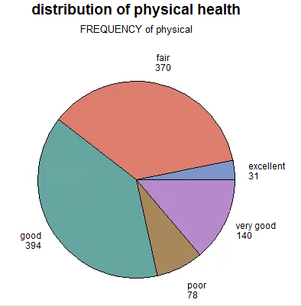

       Since we have 5-measurement scale for physical health and we want to compare their sleeping time, we decide to use ANOVA procedure. Here are the null hypothesis and alternative hypothesis:

H0: the mean of sleeping time in 5-measurement scale is same.

Ha: the mean of sleeping time in 5-measurement scale is different.

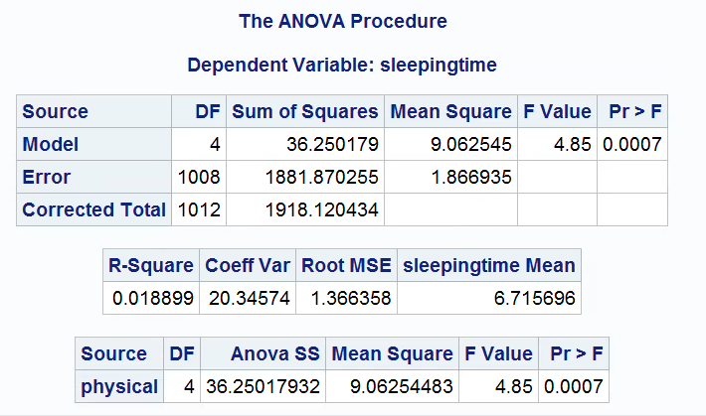

       From the output in ANOVA procedure, the P-value is 0.0007, and if we take alpha = 0.05, we need to reject the null hypothesis and have evidence to support the alternative hypothesis, which means we can prove the mean of sleeping time in 5 measurement scales are different.

       According to the second table in the above graph, we can see R-Square is 0.018899, it suggests that the linear regression line based on the explanatory variable sleeping time accounts for 1.8899% of the variability in physical scale.

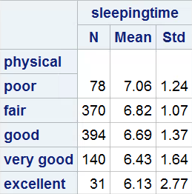

From SAS, we get the standard deviation of sleeping time in poor group is 1.24, in fair group is 1.07, in good group is 1.37, in very good group is 1.64, and it in excellent group is 2.77. As we can see, the largest standard deviation is 2.77 in excellent group, and the smallest standard deviation is 1.07 in fair group, based on one of the rules of thumb to use ANOVA procedure, which is ‘the largest sample standard deviation is no more than twice the smallest sample standard deviation’, the output we get does not meet the rule of thumb.

And the other rule of thumb is ‘the population size should be larger than 10 times of the sample size’, the sample in our observation is adults aged in 18 years or older in U.S., and there are definitely 10130 adults aged in 18 years or older in the U.S., thus our test meet the rule of thumb.

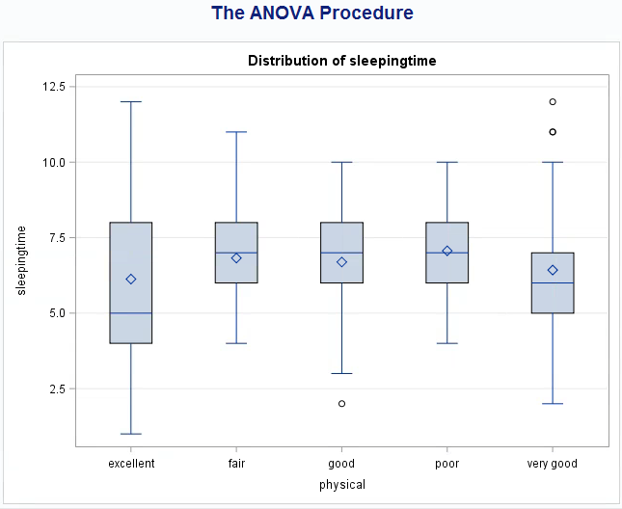

In the side-by-side boxplot, the mean of excellent group is clearly smaller than the other 4 groups, and the means of other 4 groups are similar to each other. The data in excellent group is skewed and has a large range, and there are 2 outliers in very good group.

**Sleeping time and Mental Health**

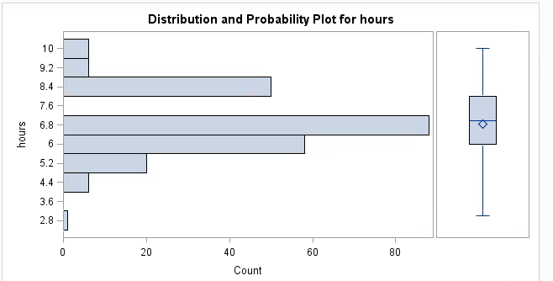

From mental=1, we can know that 80+ people have the mean sleeping time 6.8 hours, but they still feel their mental health are very terrible. Also we can see most people have poor mental health situation are in the range between 5.2 hours to 8.4 hours. Only a few people in the 2 hours and above 9 hours. The mean value of sleeping hours is a little bit below the median value.

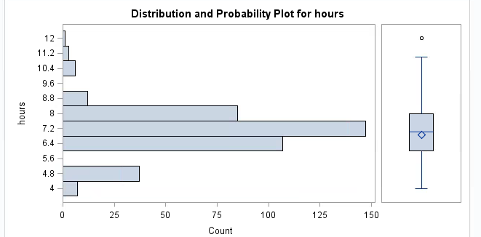

Over 140 people are in the sleeping hours between 6.8 to 7.6 hours. No people are in the range between 5.2 to 6.0 hours. The minimum sleeping hours increased to nearly 4 hours, the maximum hours also increased to 12 hours. Only one person sleep over 12 hours and feel fair about his mental health.

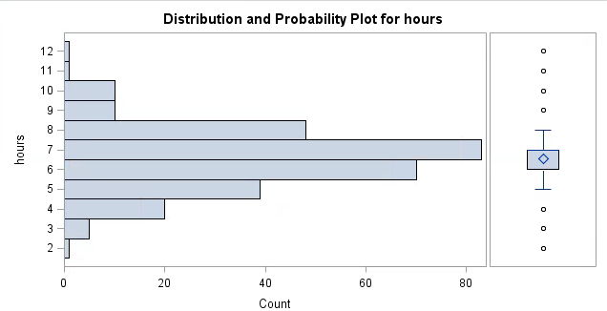

In the group that people feel good about their mental health, the most range in this group is around 7 hours. Over 80 people are in this range. One person sleep nearly 2 hours, and he even feels good about his mental health. Only two people sleep over 10 hours feels good with their mental health. Most people sleep between 5 to 8 hours can feel good with their mental health situation. There are lots of outliers in this group.

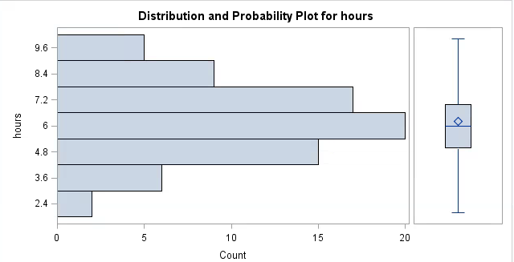

Compared with other groups, the sample size in this group is smaller. Nearly 20 people sleep around 6 hours. It’s amazing that two people only need to sleep around 2 hours to feel very good with their mental health situation. No people sleep over 10 hours. Most people are in the range between 5 to 8 hours. The mean value is a little bit bigger than the median value.

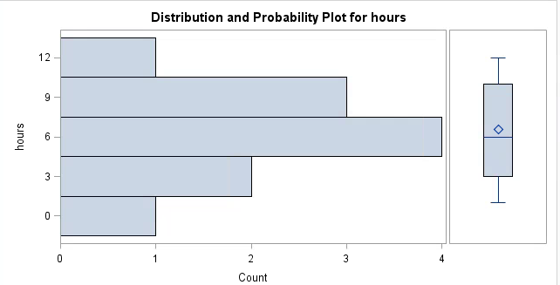

Only 11 people in this group, it’s a group that people feel excellent with their mental health situation. One person can only sleep 1 hour to feel excellent in his mental health. Another person sleep around 12 hours also feels excellent. Most people feel excellent are in the range between 4 hours to 8 hours. The mean value is also above the median value.

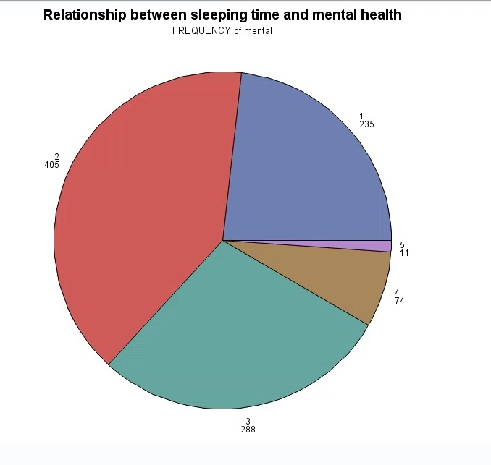

Based on the pie chart, we can see that 405 out of 1013 people who sleep under 12 hours think their mental health are fair which is the biggest part over the pie chart. 11 out of 1013 people think their mental health is excellent.

By using ANOVA procedure. Here are the null hypothesis and alternative hypothesis:

Ho: the mean of sleeping time in 5 measurement scales is same

Ha: the mean of sleeping time in 5 measurement scales is different

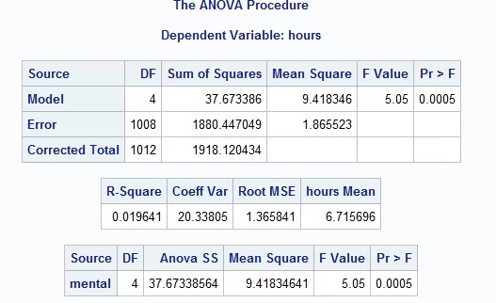

If we take alpha=0.05, since P-value=0.0005<0.05. We should reject Ho and have evidence to support Ha, which shows that the mean of sleeping time in 5 measurement scales are different.

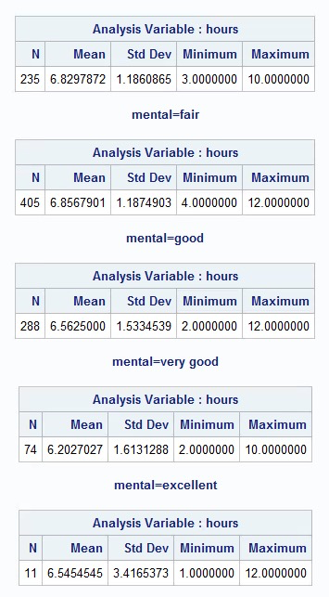

Based on the above table, we can see that R-Square is 0.019641, then 1.9641% variation of the relationship between people’s mental health and sleeping time and also shows there is a relationship between mental health and sleeping time.

From SAS, it shows that the largest standard deviation from "Excellent" / the smallest standard deviation from "Poor" is 3.4165373 / 1.1860865 = 2.88 > 2. And based on the rules of thumb to use ANOVA procedure, which is ‘the largest sample standard deviation is no more than twice the smallest sample standard deviation’, the output we get does not meet the rule of thumb. Thus, the ANOVA results are not really trustable.

In conclusion, among 5 groups, we can see that there is a weak relationship between sleeping hours and satisfaction of mental health. I thought people who sleep between 6 to 8 hours would feel best with their mental health situation. The extreme short or long sleeping hours will not make people feel good. However, some people can feel good with 1 to 2 hours sleep. Some people still feel bad with 1 to 2 hours sleep. People who sleep over 10 hours also feels poor with their mental health situation, some people who sleep over 10 hours can feel excellent with their mental health situation. Some people can feel good with 6 hours sleep, some people feel bad with 6 hours sleep. However, it is a questionnaire. So we believed it is reasonable having bias in the data. Because sometimes people won't count their own sleep hour correctly, that’s why I think there is weak positive relationship between sleeping hours and mental health.

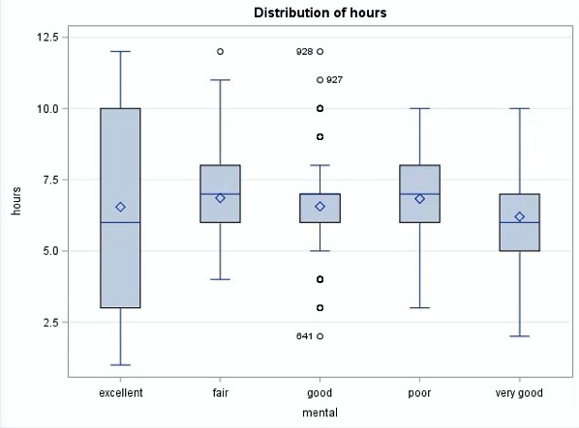

When we see the stem plot of the five groups, the mean value of these groups are approximately same. Also, in group 2, it has one outlier, and in group 3, there are 7 outliers. There are no outliers in other groups. The largest range is the group 5, almost from 1 to 12 hours. The smallest range is the group 3, except the outliers, it’s from 5 to 8 hours.

In conclusion, the sleeping hour can affect mental and physical health. However, because the scale of mental and physical health are qualitative data in our dataset, we can’t use correlation coefficient to get their relationship is positive or negative. In the other hand, there are still some potential variables affect the mental and physical health, for instance the quality of sleep and the environment of sleeping. And the data is collected from the questionnaires, everyone has different measurement of their own health situation, the data we get might be biased. Thus, we think our conclusion is reasonable but not very precise.

**Reference**

2015 Sleep and Pain. (n.d.). Retrieved April 30, 2017, from <https://sleepfoundation.org/sleep-polls-data/sleep-in-america-poll/2015-sleep-and-pain>

Separately Work:

Mental Part: Pan Xu, TaoZhe Sheng

Physics Part: Yan Zhang, Nanjing Tang

Beginning and Conclusion: together