# STAT: 2010 & 4200 Project Report (Group 21)

## Employment rate during President Obama period

**Team member:**

* Mohamad Anwar Akmal Bin Mohd Hasli
* Muhammad Muaz Fong
* Ling Zhang

**Introduction**

On this project, we’re going to do research on the employment rate of United States during the President Obama period( 2008-2015). We will research on the trend of the employment rate and compared it with other countries. The data shows the employment and unemployment rate from 3 countries of both foreign-born and native-born citizens during Obama’s presidency.

We are interested in these questions:

1. How was the trend of employment rate from 2008 to 2015? Did the employment rate get better?
2. How about the US employment rate of foreign-born people, compared to other countries?
3. People say: The immigrant is taking our jobs. Is this statement totally right? What is the relationship between unemployment rate of native-born people and employment rate of foreign-born people?

**Data description**

Source: OECD (<http://stats.oecd.org/Index.aspx?DataSetCode=MIG_NUP_RATES_GENDER#>)

Employment rates*: population aged 15-64.

Unemployment rate: active population aged 15-64.

We assume that our data are simple random samples, although the data was the result elaborately calculated from original data.

*\*Rates as defined**by the International Labour Organization.*

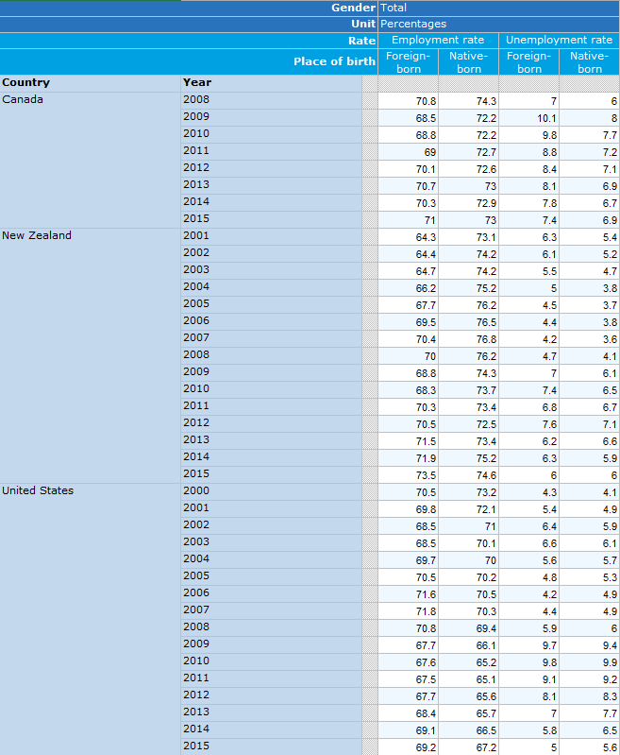

**Trend of employment rate in America**

How was the trend of employment rate of foreign-born and native-born from 2000 to 2015? Did Obama manage to increase the employment rate for the foreign citizens?

We use time plots to see the trend of employment rate of foreign-born and native-born in America.

The SAS output is as below:

*/* All the comments are denoted in this format */*

data timeplotnative;

input year $ frate nrate;

datalines;

2000 70.5 73.2

2001 69.8 72.1

2002 68.5 71

2003 68.5 70.1

2004 69.7 70

2005 70.5 70.2

2006 71.6 70.5

2007 71.8 70.3

2008 70.8 69.4

2009 67.7 66.1

2010 67.6 65.2

2011 67.5 65.1

2012 67.7 65.6

2013 68.4 65.7

2014 69.1 66.5

2015 69.2 67.2

;

run;

proc gplot data=timeplotnative;

plot frate * year =1;

symbol1 v=star c=blue;

title "Time Series Plot for 2000 ~ 2015 USA Foreign-Born Total Employment Rate";

run;

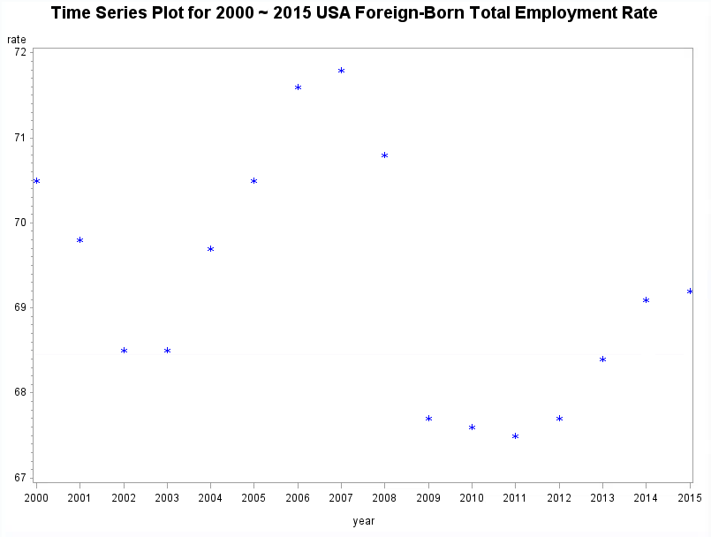

The time plot shows that the employment rate of foreign-born people changed sharply during 15 years. It increased from 2000 to 2007, and then decreased from 2008 to 2011, 2011 being the lowest one. After 2011, it increased moderately but still can’t catch up with 2000.

Even though Obama started his presidency from 2008, which coincidently was the same time the employment rate for foreign-born started to drop, we cannot say that Obama’s policies for employment were anti-secular foreign policies. We must first ask: did only the foreign-born employment rate change in this way? Let us compare that to the time plot of the native-born employment.

The SAS output is as below:

proc gplot data=timeplotnative;

plot nrate * year =1;

symbol1 v=star c=blue;

title "Time Series Plot for 2000 ~ 2015 USA Native-Born Total Employment Rate";

run;

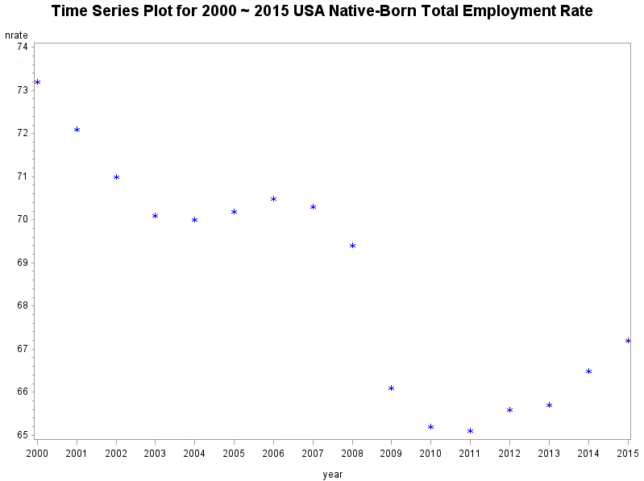

The native-born employment rate also fell from 2008-2011. From the data, we cannot conclude that there is direct correlation between Obama being the president and the falling of foreign-born employment rate. The global financial crisis happened in 2008. This is most likely a lurking variable which caused not only the foreign-born employment rate but also the native-born employment rate to sharply drop.

From the data above we cannot conclude how Obama’s policies affected the foreign-born employment rate since we know there exists a significant lurking factor (2008 financial crisis). However, since the financial crisis affected not only the US but the whole world, we can still compare how well US did, compared to other countries that have high foreign employment rate to reach a solid conclusion.

**US total foreign rate vs other countries**

We have seem the US employment rate above. Now, we are interested to compare the employment rate with the other countries during Obama presidency. How well did the US do in terms of foreign-born employment rate compared to countries with known high employment rate?

We have chosen to compare US with both Canada and New Zealand. According to our data from OECD, both these countries are have some of the highest employment rates through 2008-2015 . In addition to that, Canada is also a neighboring country of the US, helping us reduce any geographical variables that could affect the data. Define U = United State, C = Canada and Z = New Zealand. The SAS output is as below:

data employment;

input countries $ frate;

data employment;

input countries $ frate;

datalines;

C 70.8

C 68.5

C 68.8

C 69

C 70.1

C 70.7

C 70.3

C 71

Z 70

Z 68.8

Z 68.3

Z 70.3

Z 70.5

Z 71.5

Z 71.9

Z 73.5

U 70.8

U 67.7

U 67.6

U 67.5

U 67.7

U 68.4

U 69.1

U 69.2

;

run;

proc sort data=employment;

by countries;

run;

proc univariate plot data=employment;

var frate;

by countries;

run;

Check the distribution of the data for each countries.

The distribution of United State, Canada and New Zealand are as follow:

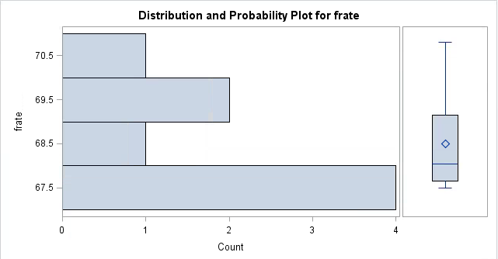

United State

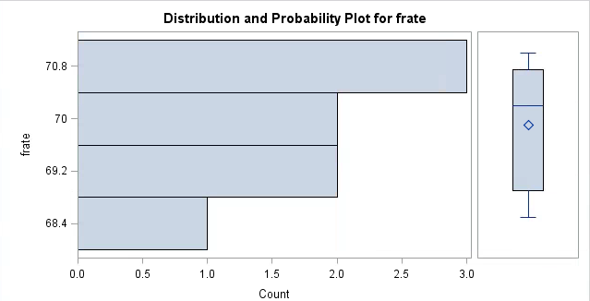

Canada

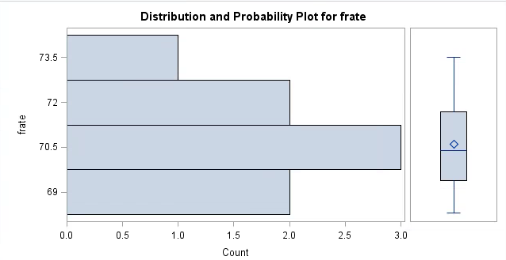

New Zealand

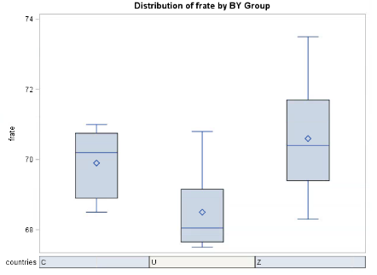

Comparative boxplot

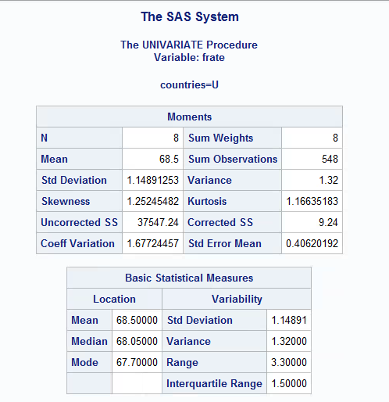

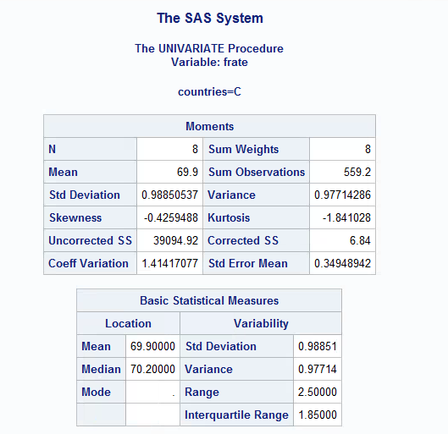

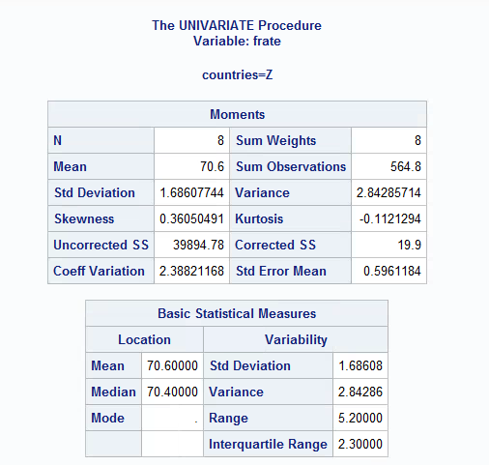

The rules of thumb for ANOVA test are met:

* All the distribution is roughly normal without extreme outlier and major skewness.
* The ratio of the largest to the smallest standard deviation is $1.6861/0.9886= 1.7055$ which is less than two.

Therefore,. It is safe for us to use ANOVA.

The SAS output as below:

proc anova data = employment ;

class countries ;

model frate = countries ;

run ;

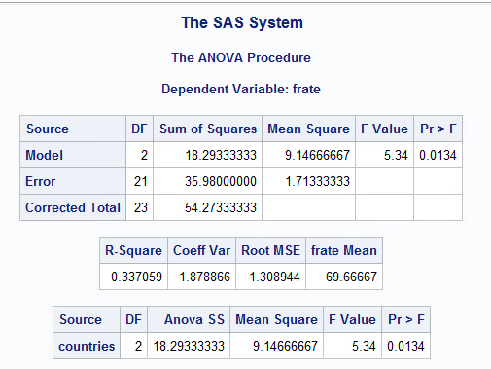

The p-value is 0.0134, less than 0.05, so we can reject the null hypothesis. Since the evidence is significant, next we use Bons test to further analyse the data and find which countries are different.

The SAS output is as below:

proc anova data = employment ;

class countries ;

model frate = countries ;

means countries / bon alpha = 0.05;

run ;

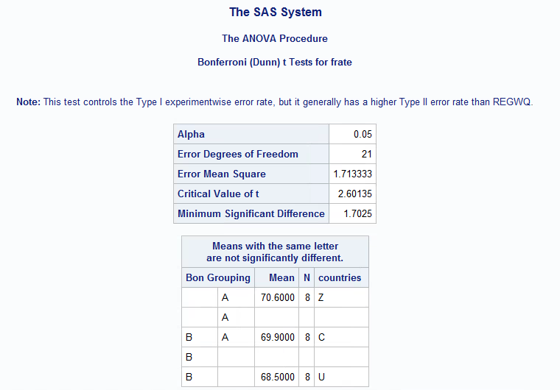

From the data, United State and Canada both have the letter A while Canada and New Zealand both have the letter B. But United States and new Zealand do not share same letter. This means that the foreign employment rate of United States is significantly different from New Zealand, but not significantly different from Canada.

Even though the foreign employment rate of the US is less than New Zealand over the 8 year period, it still managed to compete with Canada. Canada and New Zealand are both countries with high employment rate, according to the OECD data. Hence, we can conclude that the foreign employment rate of the US is pretty good, but not that good. Obama’s policies have managed to increase the foreign-born employment rate, but not terribly so.

**Is immigrant taking jobs from native people?**

People say: The immigrant is taking our jobs. Is this statement totally right? What is the relationship between unemployment rate of native-born and employment rate of foreign-born?

Step 1: plot the data to check the relationship: unemployment rate of native-born vs. employment rate of foreign-born.

The SAS output;

data relationship;

input year $ unempnative empforeign;

datalines;

2000 4.1 70.5

2001 4.9 69.8

2002 5.9 68.5

2003 6.1 68.5

2004 5.7 69.7

2005 5.3 70.5

2006 4.9 71.6

2007 4.9 71.8

2008 6 70.8

2009 9.4 67.7

2010 9.9 67.6

2011 9.2 67.5

2012 8.3 67.7

2013 7.7 68.4

2014 6.5 69.1

2015 5.6 69.2

;

run;

proc plot data=relationship;

plot unempnative * empforeign ='*' /vpos=20 hpos=40;

title "Plot for Unemployment Rate of Native-born People vs. Employment Rate of Foreign-born People";

run;

quit;

title;

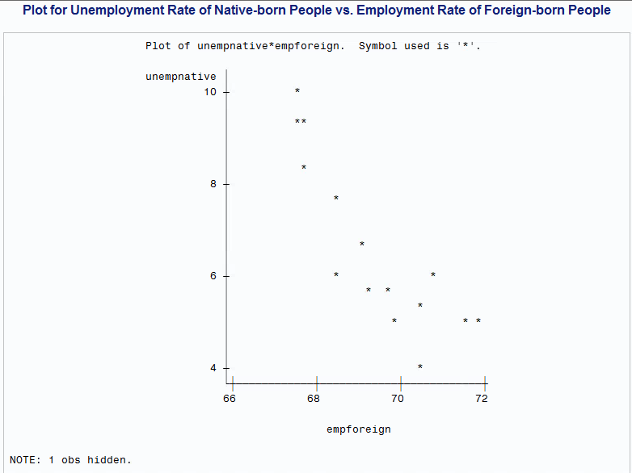

From the scatterplot, it shows there is a negative and roughly linear relationship between employment rate of native-born and unemployment rate of foreign-born.

Step 2: calculate the correlation coefficient between unemployment rate of native-born and employment rate of foreign-born.

The SAS output is below:

proc corr data=relationship;

var unempnative empforeign;

run;

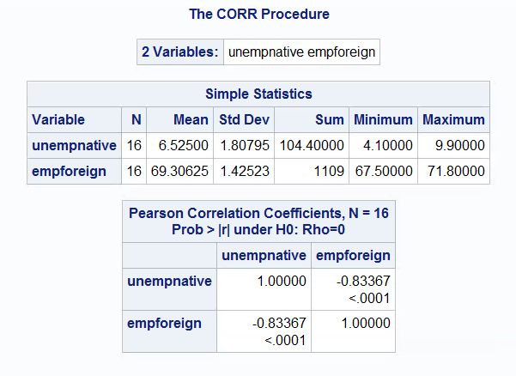

The correlation coefficient is -0.83367. Since the correlation is very high, it indicates there is a very strong negative linear relationship between employment rate of foreign-born and unemployment rate of native-born.

Step 3: apply linear regression. Let y: unemployment rate of native-born, x: employment rate of foreign-born.

The SAS output:

proc reg data=relationship;

model unempnative = empforeign /p;

id year;

run;

plot residual. * predicted. / symbol='*' hplots=2 vplots=2;

run;

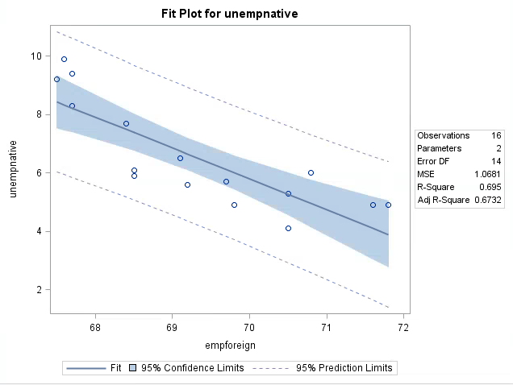

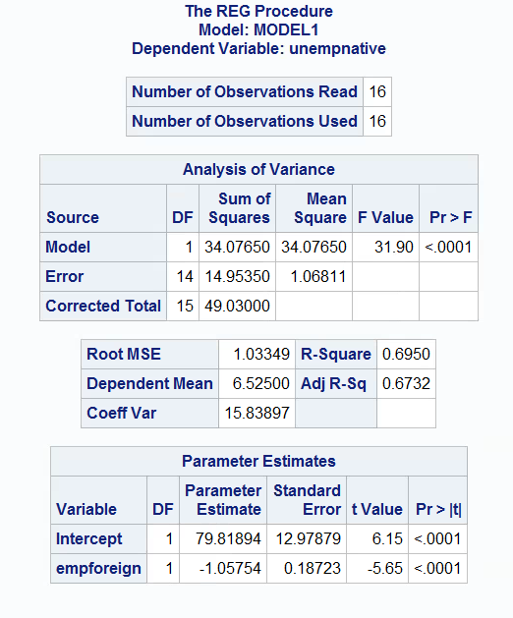

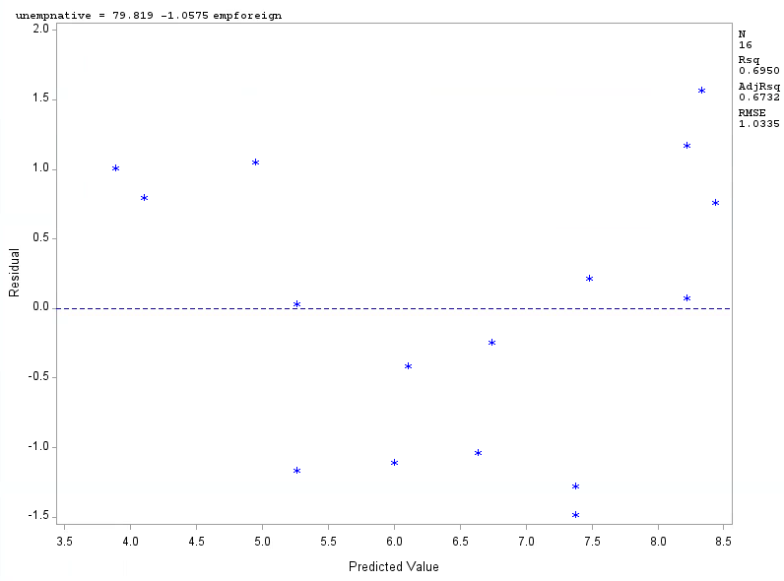

Both of the parameter estimates’ p-values < 0.0001, so we can reject that the parameters are equal to zero.

The linear regression model: **unempnative = 79.82-1.06*empforeign**.

It means that for a 1% increase in employment rate of foreign-born, we would expect 1.06% decrease in unemployment rate of native-born. Coefficient of determination: 0.695, so 69.5% of the variability in number of unempnative is explained by number of empforeign.

**Conclusion**

From the data, we can conclude that Obama’s policies were helpful to increase foreign-born employment rate in US. Although it is not as high as New Zealand, but it is very close to Canada, which was an achievement. Another conclusion is that the immigrant is not always taking jobs from native-born people in the US because the data shows a clearly negative relationship between employment rate of foreign-born and unemployment rate of native-born. That is interesting. It needs a further research to discover more details.