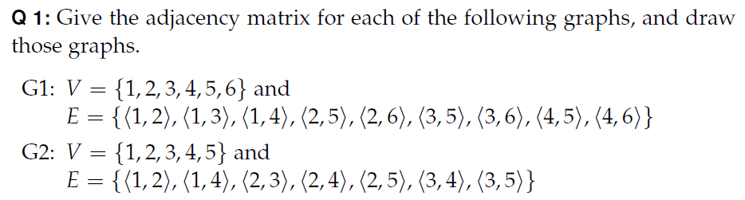
Draw the line graph for G1, L(G1)

