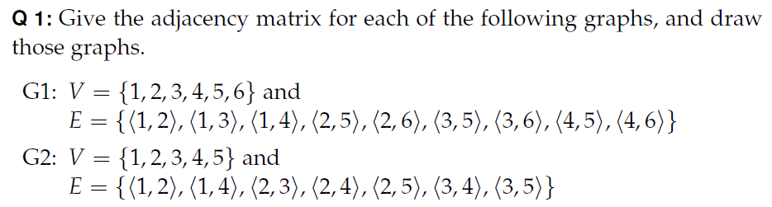
For the graph G1, the neighborhood of vertex 1, N(1) = _________
the degree of vertex 1 is _________
Draw the subgraph induced by the vertices {1, 2, 4, 5}

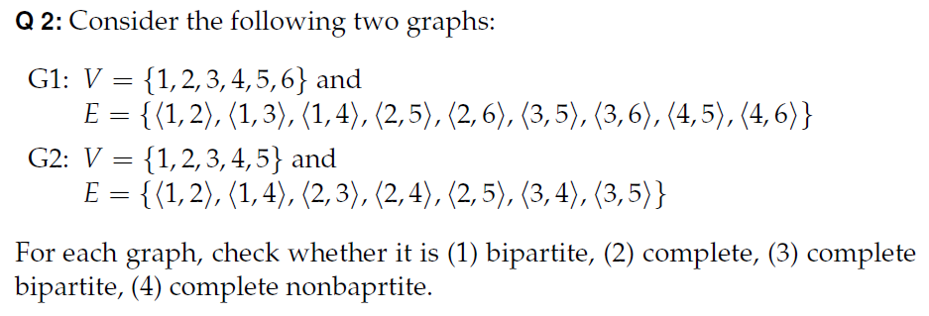

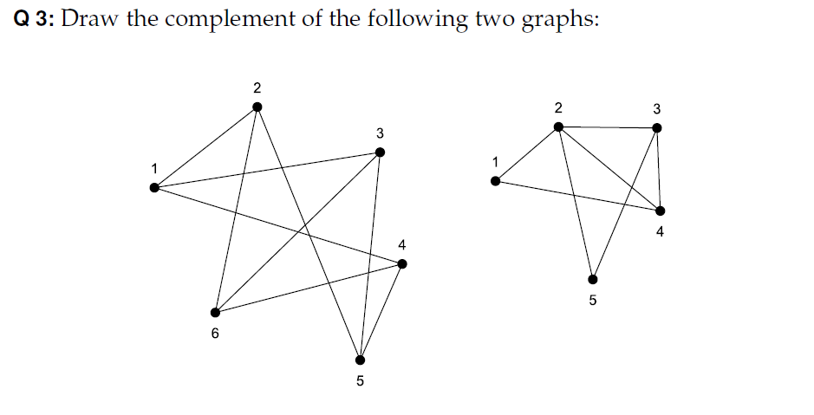

Give an example of a complete graph with 5 vertices.

Give an example of a 3-regular graph.

Give an example of a bipartite graph with 6 vertices

Give 2 examples of complete bipartite graphs with 5 vertices

