HW 4: Due Wednesday Feb 6th
Please check your answers.
Please label all problems clearly (i.e., Q7, Q8, …)
Please include your first and last name and the name of the assignment on your paper (e.g., "HW4").
Please write neatly and clearly, using full sentences. Practice pretending this is a real job for which you want your HW to look professional.
Note: answers in van Steen (and many if not most math books) are often incomplete (outlines as opposed to complete proofs). Please define all terms.

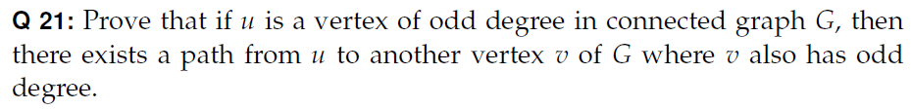
Note: van Steen gives 2 answers. First answer is best since it is shorter.
