y’ = y^{1/3}
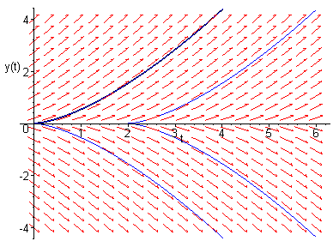
Figure 2.4.1 from Elementary Differential Equations and Boundary Value Problems, Eighth Edition by William E. Boyce and Richard C. DiPrima

