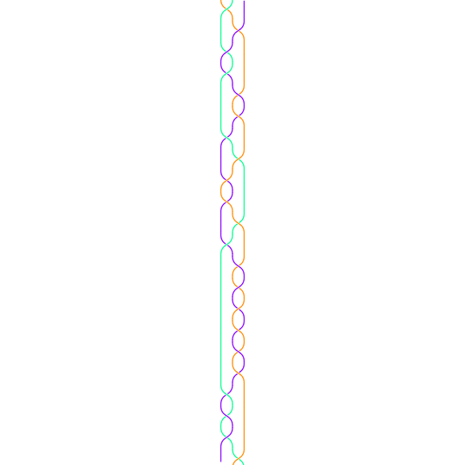22M:096: Intro to Math Research: Applied Knot Theory Undergraduate course, Spring 2010, MWF 1:30 – 2:20pm

This course introduces undergraduates to research in mathematics. It is open to any student who has passed Calculus I and II (or 22M:016 Calc for Bio or consent of instructor).

Knot theory is a fascinating and accessible research area sometimes used to introduce K-12 students to an active research area in mathematics. Knot theory has applications to the study of DNA topology, DNA-protein interactions, and protein folding. Students will have the option to pick one of many clearly defined research problems or develop their own. Projects may involve proving mathematical theorems, developing computational tools, modeling biological problems, or a combination of these. Students may choose to work in groups or on their own.

Paid Summer research opportunities to continue working on a research project started in this course may be available.

The above equation models the shape of DNA bound by protein [Pathania S, Jayaram M, Harshey R, Cell. 2002 109(4):425-36; D et al BMC Bioinformatics. 2006 Oct 5;7:435].

Students will have the opportunity to

1. Work on a research project and potentially submit an article to an undergraduate or research journal.
2. Learn to work in an interdisciplinary
3. Develop web page of knot invariants of use to biologists and mathematicians.