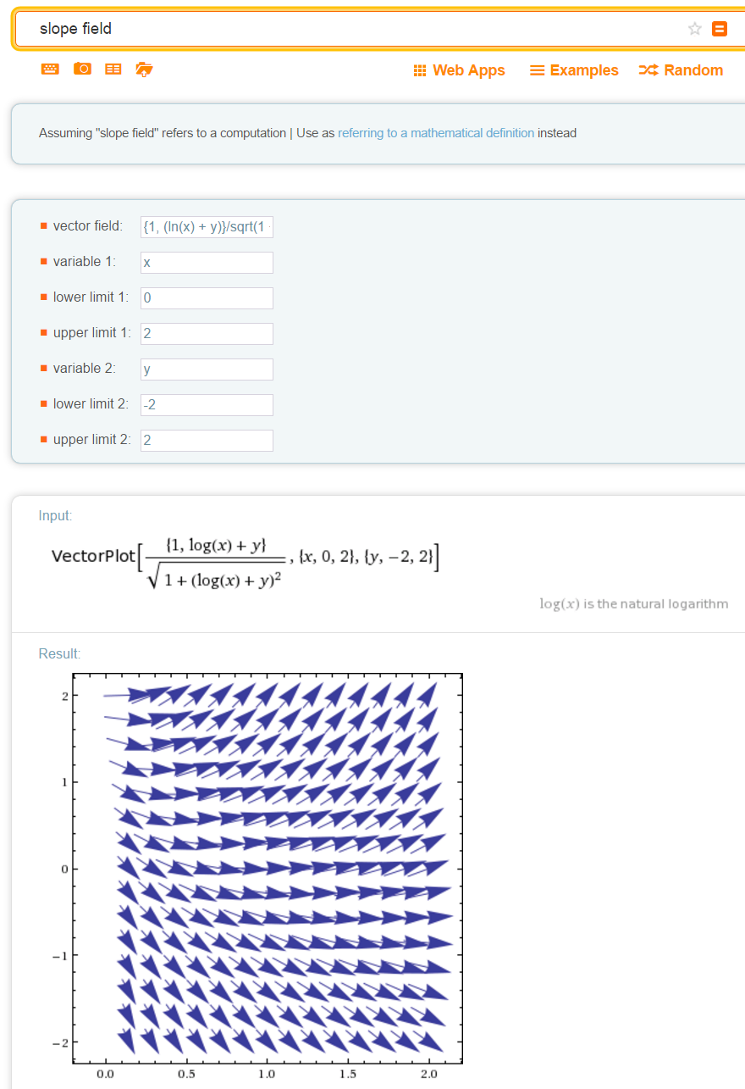
http://www.wolframalpha.com

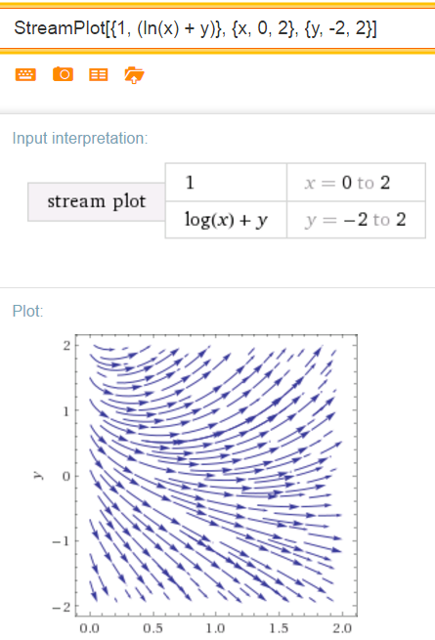
{1, (ln(x) + y)}/sqrt(1 + (ln(x) + y)^2)
Do NOT curve
your slope lines
Slope lines are small portions of lines tangent to a solution. Thus slope lines must be straight. They cannot be curved.
Arrows are optional

